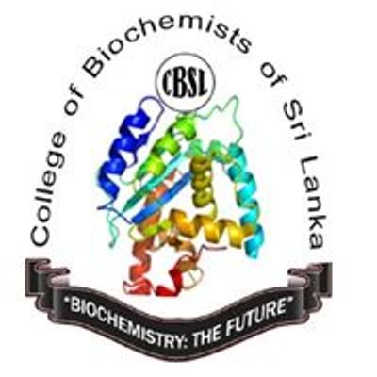
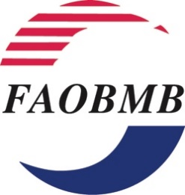

APPLICATION FORM

Young Scientist Program
28th FAOBMB and 2nd CBSL Conference
on 10th June 2020 at Hilton Hotel, Colombo, Sri Lanka

Name of Applicant: Mr / Mrs/ Ms / Dr ……………………………………………………….

Gender:

Position:

Address of Applicant:
(institutional or office address)

Email address:

Contact No:

Membership of College of Biochemists Sri Lanka:
Indicate the category of membership and membership number.
* Only members of CBSL are eligible to register for YSP. To get the membership visit CBSL website: https://www.collegeofbiochemists.lk/

APPLICANT’S DECLARATION

I hereby declare that all the information given above and any other supplementary information attached in connection to my application, whether on this document or not, are accurate and to the best of my knowledge true and correct. I understand that any misrepresentation, falsification, or omission of information would result in the disqualification of my application for Young Scientist Award, 28th FAOBMB and 2nd CBSL Conference.

Signature of Applicant | Endorsement by supervisor/HOD (to sign)
Date | Name:  Position:  Date:

